How to Generate a Certificate Signing Request File

Introduction:
The commands and procedure below details the required commands and requirements to generate a certificate request and also explains where to put the returned certificate from Comodo. This procedure assumes that the web server, PHP, MySQL and server configuration have already been performed for the Courier build. These instructions can be sort from the Installation instructions or the Installation scripts themselves.

Generate the Certificate Signing Request File:
To generate the certificate signing request file, commonly known as the CSR file, you need to have the server key to enable you to reference this in the command and also it ties the certificate file to this server. On the command line as root type the following command:
- openssl req -new -key server_key_name.key -out certificate_request_file.csr

This will start the command line questions which should be completed as required. An example of the questions and possible answers is listed below for completeness but each server will be different depending on server settings and DNS:
- Country Name (2 letter code) [US]: GB
- State or Province Name []: North Somerset
- Locality (City) Name []: Clevedon
- Company (Organisation) Name []: ISEEU Global Limited
- Department Name []: Information Technology
- Server Host Name []: server-DNS-name.iseeuglobal.com
- Administrators E-mail address []: technical@iseeuglobal.com
- Please enter the following 'extra' attributes
- to be sent with your certificate request
- A challenge password []: <LEAVE BLANK AND HIT RETURN>
- An optional company name []: <Company Name if installed On Site e.g. Bristol Hospital>

The certificate signing request is produced and saved to the path specified on the command line, and this can be parsed with the following command to check for errors:
- openssl req -noout -text -in certificate_request_file.csr

The output from the above command parses the file to give real output to allow for error checking. However you need the raw text to enable you to add this to the Certificate Authorities web site to actually request a real certificate. A raw output can be achieved with the following command:
- cat certificate_request_file.csr

This output looks similar to the example given below but likely to be longer:
-----BEGIN CERTIFICATE REQUEST-----
MIIBnTCCAQYCAQAwXTELMAkGA1UEBhMCU0cxETAPBgNVBAoTCE0yQ3J5cHRvMRIw
EAYDVQQDEwlsb2NhbGhvc3QxJzAlBgkqhkiG9w0BCQEWGGFkbWluQHNlcnZlci5l
eGFtcGxlLmRvbTCBnzANBgkqhkiG9w0BAQEFAAOBjQAwgYkCgYEAr1nYY1Qrll1r
uB/FqlCRrr5nvupdIN+3wF7q915tvEQoc74bnu6b8IbbGRMhzdzmvQ4SzFfVEAuM
MuTHeybPq5th7YDrTNizKKxOBnqE2KYuX9X22A1Kh49soJJFg6kPb9MUgiZBiMlv
tb7K3CHfgw5WagWnLl8Lb+ccvKZZl+8CAwEAAaAAMA0GCSqGSIb3DQEBBAUAA4GB
AHpoRp5YS55CZpy+wdigQEwjL/wSluvo+WjtpvP0YoBMJu4VMKeZi405R7o8oEwi
EAYDVQQDEwlsb2NhbGhvc3QxJzAlBgkqhkiG9w0BCQEWGGFkbWluQHNlcnZlci5l
eGFtcGxlLmRvbTCBnzANBgkqhkiG9w0BAQEFAAOBjQAwgYkCgYEAr1nYY1Qrll1r
uB/FqlCRrr5nvupdIN+3wF7q915tvEQoc74bnu6b8IbbGRMhzdzmvQ4SzFfVEAuM
MuTHeybPq5th7YDrTNizKKxOBnqE2KYuX9X22A1Kh49soJJFg6kPb9MUgiZBiMlv
tb7K3CHfgw5WagWnLl8Lb+ccvKZZl+8CAwEAAaAAMA0GCSqGSIb3DQEBBAUAA4GB
PdlrrliKNknFmHKIaCKTLRcU59ScA6ADEIWUzqmUzP5Cs6jrSRo3NKfg1bd09D1K
9rsQkRc9Urv9mRBIsredGnYECNeRaK5R1yzpOowninXC
-----END CERTIFICATE REQUEST-----
The above can now be added to the Comodo (or other Certificate Authority) web site to request that a certificate be produced and sent to you after validation. Screen shots showing this are detailed below as far as possible without actually requesting a certificate due to cost implications:

In a browser navigate to www.comodo.com and click in the top right of the screen to login.

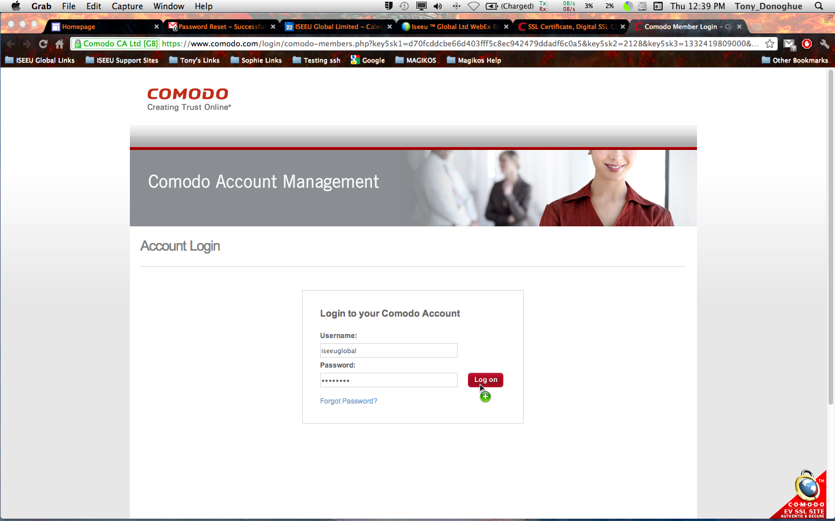
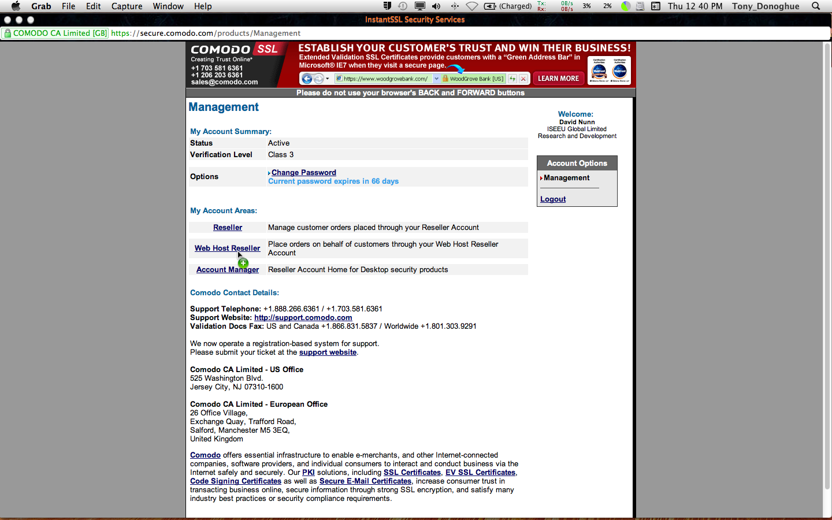
A new window opens where you can enter the login credentials (see password file/notes) and click the login button.

Another window opens which is easier if you make it full screen. On this you can choose Web Host Reseller option.
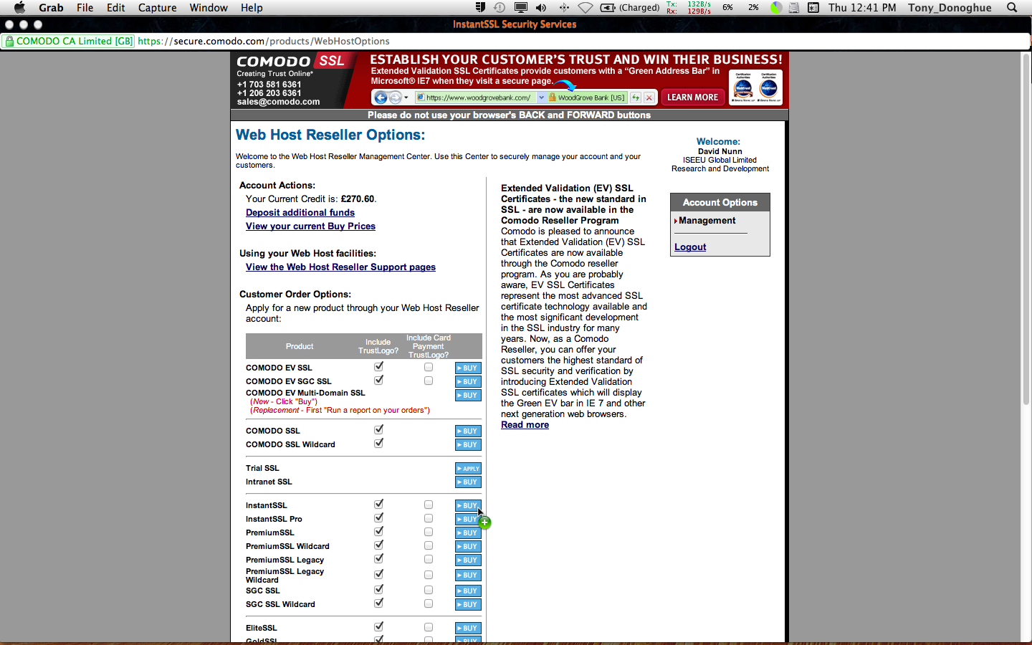
Choose the type of certificate you want which is normally Instant SSL and click the Buy button.
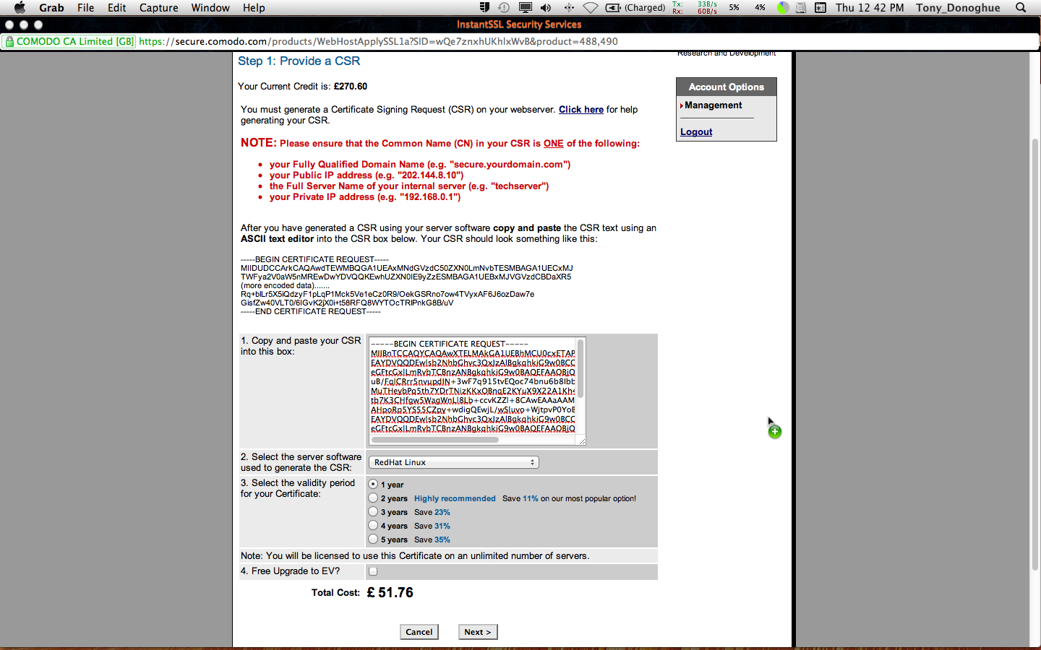
Copy in the raw text from the certificate signing request file made earlier.
Choose Red Hat Linux from the drop down menu to say how the file was created.
After you choose how long you want to have the certificate last (normally only 1 year for standard contract lengths) you can click on next at the bottom

The next screen can't be produced with an image as it would commit the certificate but it displays the parsed output from the raw file for you to review. Once happy and completing any further parts to the address forms that it may have missed, you get to confirm how you would like to validate the certificate. This is normally done via the Email address entered into the certificate signing request questions earlier. This is the most reliable way to validate the domain and sends a validation Email to the email address. Follow the instructions in the Email to validate the request (normally clicking a link and cutting and pasting the validation key) – after which within normally 24 hours the certificates are sent to the technical@iseeuglobal.com Email address for adding to the server.

